TITLE OF THE PAPER
→(Times New Roman, bold, 16, capital, centered)

Authors (Name and surname, all in the same line) →(Arial Narrow, normal, 10)

Affiliation of each of the authors: university, institution, department, title, postal address and phone number, email …→(Arial Narrow, normal, 10)

Received: DD/MM/YY - Reviewing: DD/MM/YY - Accepted: DD/MM/YY - DOI: http://dx.doi.org/10.6036 (To be completed by Editor)

TITULO DEL ARTICULO EN ESPAÑOL
(Times New Roman, negrita, 16, mayúscula, centrado)

ABSTRACT: →(Arial Narrow, Negrita, 10)  The abstract of the paper in English, will be of a maximum length of 300 words, better the shorter, clearer, more attractive and easier to understand even by the non-experts in that matter, highlighting the objectives of the work described rather than its scientific processes and always considering those objectives within the concept of the DYNA Journal. →(Arial Narrow, negrita, 9)  Keywords: 5-10 short words or short phrases identifying the content of the work for inclusion in national and international directories and databases →(Arial Narrow, negrita, 9) | RESUMEN: →(Arial Narrow, negrita, 10)  El Resumen del trabajo en español, será de una extensión máxima de 300 palabras, mejor cuanto más breve, claro, atractivo y fácil de entender incluso por lo no expertos en esa materia, remarcando los objetivos del trabajo descrito más que sus procesos científicos y siempre considerando esos objetivos dentro del concepto de la Revista DYNA →(Arial Narrow, normal 9)  Palabras clave: 5-10 palabras o frases cortas que identifiquen el contenido del trabajo para su inclusión en los repertorios y bases de datos nacionales e internacionales →(Arial Narrow, normal, 9)

1. INTRODUCTION →(Arial, bold, 12, capital letter)

It should include the rationale and purpose of the study with the current state of the technology addressed, making reference to bibliographic citations that are strictly necessary. It shall not include data or conclusions of the work presented.

The Introduction should show the reasons for the paper's work and the concrete and practical objectives, whether it is research, good practice or state-of-the-art technology. It is not enough to consider as an objective the description of a work carried out without any consequences other than those of its execution, even if it is technically correct. It must present definite perspectives that this work represents a positive contribution to engineering and industry. The language and terms used in this section should be understood by a broad spectrum of readers, even if they are not experts. → (Times New Roman, normal, 10)

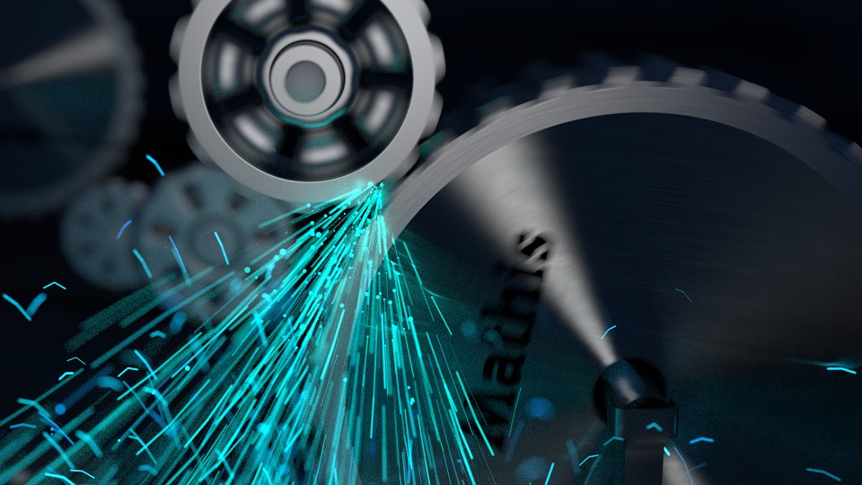

Fig. 1. Machine working → Times New Roman, normal, 10, cursive

Tabla I . Quantity table → Times New Roman, normal, 10, cursive

Images, tables, diagrams or graphics should preferably be placed as indicated. If they need a larger size to be visible, they will be provided separately by placing only the feet in the desired place. The font for the tables and figures shall be Arial Narrow size 9

The equations will be expressed by leaving dividing lines between the preceding and subsequent text:

$w_{k}=\text{16},\text{76}+\text{270}⋅p_{1^{2}}+\text{698},\text{42}⋅p_{4}$ (1)

If they are numbered, give the number to the If they exceed the line length, they will be provided separately by placing only the number in the desired place.

Care should be taken to ensure that references to bibliography throughout the text indicate the sequence and identification number as abbreviated as possible, and this should be done when the fundamental ideas are provided, without excessive repetitions that reduce space and make reading overwhelming.. →(Times New Roman, normal, 10)

2. TOOLS Y METHODS →(Arial, bold, 12, capital letter)

The tools used to carry out the work will be presented with the precision that is convenient for the reader to understand and confirm the development of research or the presentation of good practices. Previously published methods should be described only briefly and provide the corresponding citations, unless the authors have made changes in the same used in their case. If this is an original methodology, it is necessary to explain the reasons for its use and describe its possible limitations. In this section, language may be the scientifically or technically necessary.

Images, tables, diagrams or graphics should preferably be placed as indicated in the previous section. In case they need a larger size to be visible, they will be provided separately by placing only the feet in the desired place.

The equations will be expressed by leaving dividing lines between the preceding and subsequent text. If they are numbered, give the number at the end of the line and take care of the consecutive numbering. If they exceed the line length, they will be provided separately by placing only the number in the desired place, as indicated in the previous section. →Times New Roman, normal, 10

Care should be taken that references to bibliography throughout the text indicate the serial number and identification number in the shortest possible way, and this should be done when the fundamental ideas are provided, without excessive repetitions that reduce space and make reading overwhelming.

This section admits other titles at the choice of the authors, such as Development, Execution, etc.? →Times New Roman, normal, 10

3. RESULTS →(Arial, bold, 12, capital letter)

They will appear with a logical sequence text, and if they occur in tables, graphs, etc., the same data should not be repeated in it. Efforts will be made to highlight the most important observations, describing, without interpreting or making value judgments, those made on the material and methods used.

Images, tables, diagrams or graphics should preferably be placed as indicated in the previous section. In case they need a larger size to be visible, they will be provided separately by placing only the feet in the desired place.

The equations will be expressed by leaving dividing lines between the preceding and subsequent text. If they are numbered, give the number at the end of the line and take care of the consecutive numbering. If they exceed the line length, they will be provided separately by placing only the number in the desired place, as indicated in the previous section.

Care should be taken to ensure that references to bibliography throughout the text indicate the sequence and identification number as abbreviated as possible, and this should be done when the fundamental ideas are provided, without excessive repetitions that reduce space and make reading overwhelming. →(Times New Roman, normal, 10)

4.- DISCUSION →(Arial, bold, 12, capital letter)

In the discussion, the results presented will be analyzed in the shortest possible way, relating them to the current situation or other studies with the advantages and disadvantages of each one. Do not repeat in any case data or ideas already discussed.

Images, tables, diagrams or graphics should preferably be placed as indicated in the previous section. In case they need a larger size to be visible, they will be provided separately by placing only the feet in the desired place.

The equations will be expressed by leaving dividing lines between the preceding and subsequent text. If they are numbered, give the number at the end of the line and take care of the consecutive numbering. If they exceed the line length, they will be provided separately by placing only the number in the desired place, as indicated in the previous section.

It is essential that reference be made in this section to the specific objectives and/or contributions to Engineering and Industry mentioned in the Introduction, as well as to their possible actual application and future continuity. The language and terms used must be understood by a broad spectrum of non-expert readers.

Care should be taken that references to bibliography throughout the text indicate the serial number and identification number in the shortest possible way, and this should be done when the fundamental ideas are provided, without excessive repetitions that reduce space and make reading overwhelming.

This section admits another title of the authors' choice, as Conclusions. →(Times New Roman, normal, 10)

OTHER SECTIONS:

REFERENCES →(Arial, bold, 12, capital letter)

The bibliography should follow the discussion or acknowledgments if any. The accuracy of references is the responsibility of the author. If references are DOI (Digital Object Identifier) is compulsory inclusion in each. You can include as references papers accepted but not yet published, specifying the name of the publication followed by the words "in press".
The citation system is detailed in Instrucciones para los Autores of the Journal DYNA.
Please take as example:
[1] Mindeguia JC, Pimienta P, Noumowé A, et al. “Temperature, pore pressure and mass variation of concrete subjected to high temperature — Experimental and numerical discussion on spalling risk”. Cement and Concrete Research. March 2010. Vol. 40-3. p.477–487. DOI:10.1016/j.cemconres.2009.10.011 → (Arial Narrow, normal, 9)
[2] Ye G, Liu X, De Schutter G, et al. "Phase distribution and microstructural changes of self-compacting cement paste at elevated temperature". Cement and Concrete Research. June 2007. Vol.37-6. p.978-987. (doi:10.1016/j.cemconres.2007.02.011 ) → (Arial Narrow, normal, 9)

ACKNOWLEDGE →(Arial, bold, 12, capital letter)

Only persons or entities that have made substantial contributions to the study but do not merit the qualification of author or collaborators will be thanked for their collaboration, and the author must have their written consent. In the case of funded research, authors are encouraged to explicitly cite the funding source.. →( Arial Narrow, normal, 9)

SECTIONS FORMAT AND FONTS USED:
1. TITLE, SECTION 1 →(Arial, bold, 12, capital letter)
1.1. TITLE SECTION 2 →(Arial, normal, 12, capital letter)
1.1.1. Title section 3 →(Arial, bold, 11, small letter)
1.1.1.1. Title paragraph 4→(Arial, normal, 11, small letter)
Paper body text → (Times New Roman, normal, 10, small letter)
OTHER INDICATIONS:
This template contains the default margins, styles, spacing ... To use this template, open it and save it under a new name. From that point you can replace images and text for the content of your paper, while preserving the styles and formatting necessary.
To view the styles of this template, click the Format menu and then on "Styles and Formatting".

